The futility of mercantilist wars. A case study of France and Hamburg between 1713 and 1820

Guillaume Daudin Elisa Tirindelli

Université Paris-Dauphine PhD student at Trinity College Dublin

guillaume.daudin@dauphine.fr [tirindee@tcd.ie](mailto:tirindee@tcd.ie)

Is mercantilist warfare effective in its own terms, by crippling trade of defeated powers? Our paper explores the Anglo-French experience during the eighteenth century and contributes to understanding why that was not the case.

Jefferson famously noticed that European nations « were nations of eternal war» (1823). Indeed, from 1700 to 1825, 2 years out of 3 experienced conflict between major European powers (<https://ourworldindata.org/war-and-peace/)>. Rivalry between Great-Britain and France was central, so much as the period between 1688 to 1815 was called the « 2nd Hundred Years War » 1688-1815. War has many causes. Yet, especially after the death of Louis XIV, it cannot be denied mercantile rivalry was an important motivation of Anglo-French wars. (Crouzet 2008, Wallerstein 1980…). Each nation was jealous of the other’s commercial success. The British believed war was a good way to curtail them. The French partly agreed and were more wary of wars because they did not have much naval success.

Here is the long list of wars between France and Britain after the death of Louis XIV : War of the Polish Succession (1733-1738), War of the Austrian Succession (1740 (naval hostilities started in 1744)–1748), Seven Years' War (1756–1763), War of American independence (1775 (French involvement started in 1778)–1783), French Revolutionary Wars (1792–1802) and Napoleonic Wars (1803–1815). Yet, all these wars were in vain before the 1790s, as French trade was resilient and was not moved out of its pre-1744 trend (Figure 1). Things changed after 1807.

Figure : Total French trade and Anglo-French wars

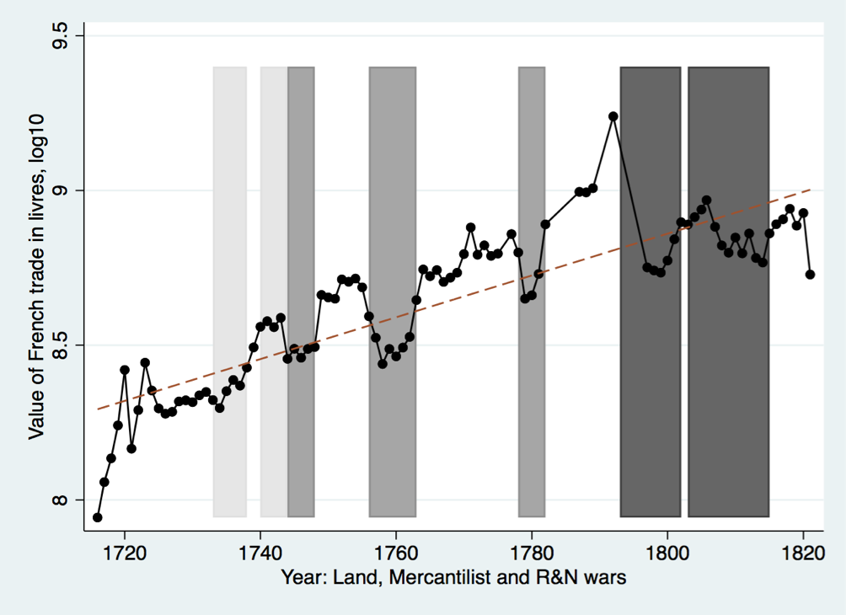

Source: TOFLIT18 database. Note: inflation was low before 1792

How come the pre-1792 wars did not have a lasting effect on French trade? This is important to understand the effect of wars in general, the geopolitical history of the eighteenth and nineteenth century and the globalization/deglobalization cycle from the 1490s to the 1840s.

The existing literature looking at the impact of wars on neutral trade comes to mixed results. Barbieri and Levy (1999) for example, analyse the impact of war from 1870 to 1992, and find that the general impact of conflict on trade is not particularly strong and mostly only temporary. Anderton and Carter (2001), on the other hand, look at the effect of wars on global trade, and find that when major world power are at war significant pre and post war effects are observed. Finally, Rahman (2007), using British trade data from eighteenth century, finds that it is warfare between naval powers that brings disruption to trade. In contrast, the resilience of French trade has long been remarked by historians (Riley (1984)).

We use a new database of French trade statistics to explore this question (http://toflit18.hypotheses.org) Our contribution is to distinguish trade with neutrals, allies and foes, (focusing on Hamburg, which was neutral during the period), and to look at sectoral level of trade. To our belief we are the first ones to look at the effect of wars on good-specific bilateral trade flows. We are looking in particular at coffee and sugar, which are the major colonial goods, and at wine and eau de vie, major European products. We focus, on the particular case of Hamburg, for two reasons. First, it offers import trade statistics that allow double checking the French data (Figure 2). Second, it was an important trade partner, a neutral gateway to Germany whose trade was mainly directly affected by war. We then repeat the experiment on all French trading partners as an aggregate. We also explore whether the effect of war depends on the identity of the victor and the belligerent status of trade partners.

Figure : French exports to Hamburg (or «Le Nord») measured by Hamburg (or French) statistics (1787=1 in both case)

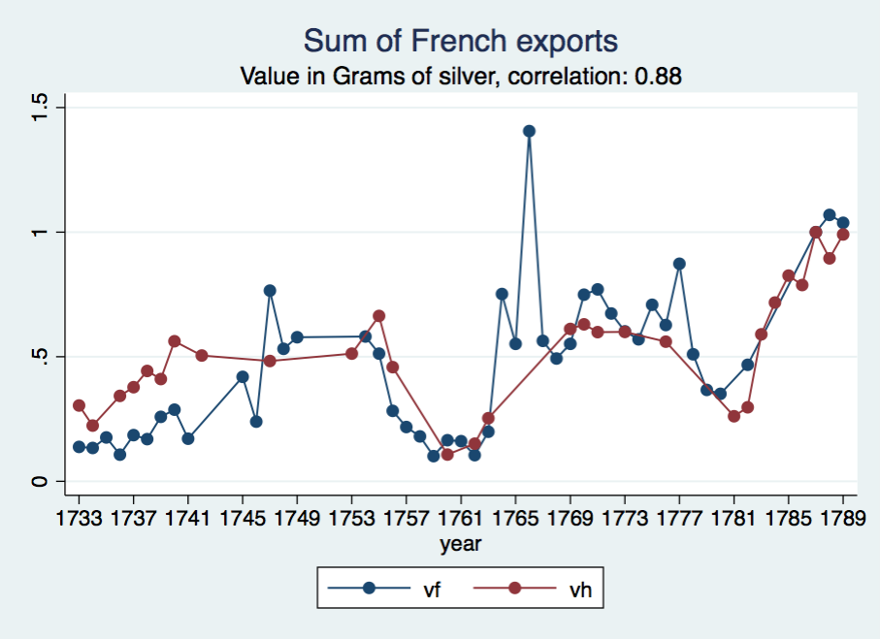

We find a general negative impact of war on French exports to Hamburg and all aggregate trading partners, yet, we observe big differences depending on the products. Wars have a very large and negative impact on colonial products, but a positive one on wine (and a very positive one on eau-de-vie). This suggests that trade of some specific products was benefitting from wars. Furthermore, we find little long-term effect of wars before 1793. It was not possible for the United Kingdom to cripple French trade before the ideological wars that started after the Revolution.

Table : The effect of war on French exports to “Le Nord”

|  |  |  |  |  |
| --- | --- | --- | --- | --- |
|  | goods FE and time-trends | goods FE and time-trends with break in 1795 | goods FE and time-trends | goods FE and time-trends with break in 1795 |
| War # Coffee | -3.35*** | -1.51*** |  |  |
| War # Eau de vie | 0.32 | 0.31 |  |  |
| War # Sugar | -1.65*** | -1.05*** |  |  |
| War # Wine | -0.57 | -0.49 |  |  |
| War # Other | -0.10 | -0.10 |  |  |
| Land_war # Coffee |  |  | -4.16*** | -2.34*** |
| Land_war # Eau de vie |  |  | -0.27 | -0.24 |
| Land_war # Sugar |  |  | -0.03 | 0.20 |
| Land_war # Wine |  |  | -1.10* | -1.08* |
| Land_war # Other |  |  | 0.31 | 0.32 |
| Mercantilist_war # Coffee |  |  | -1.90*** | -1.88*** |
| Mercantilist_war # Eau de vie |  |  | 0.26 | 0.16 |
| Mercantilist_war # Sugar |  |  | -0.92* | -1.80*** |
| Mercantilist_war # Wine |  |  | -0.12 | -0.21 |
| Mercantilist_war # Other |  |  | -0.30 | -0.33 |
| R&N_war # Coffee |  |  | -5.12*** | 1.62 |
| R&N_war # Eau de vie |  |  | 0.90 | 1.22* |
| R&N_war # Sugar |  |  | -5.61*** | -0.84 |
| R&N_war # Wine |  |  | -0.73 | -0.45 |
| R&N_war # Other |  |  | -0.17 | -0.08 |
| Observations | 409 | 409 | 409 | 409 |
| R-squared | 0.39 | 0.65 | 0.51 | 0.68 |

Keywords: international trade, 18th century, France, Hamburg, warfare